HANOI UNIVERSITY OF SCIENCE AND TECHNOLOGY
School of Information and Communication Technology

Object-Oriented Programming (IT3100 / IT3040)

LABORATORY REPORT 01

Student Information
- Full name: Le Viet Anh
- Student ID: 202416774
- Class: 757054
- Instructor: Ho Viet Duc Luong

1. Objectives
The objective of this laboratory is to get familiar with:
- Basic Java syntax
- Input/output operations in Java
- Using Scanner and JOptionPane
- Conditional statements and loops
- Simple mathematical and array operations

2. Exercises Implementation and Results

Exercise 2.2.5 – Simple Calculator
Description:
This program takes two real numbers as input and performs four basic operations: addition, subtraction, multiplication, and division. The results are displayed using dialog boxes.
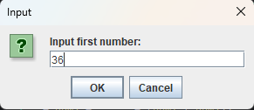
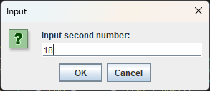
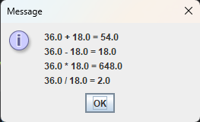

Exercise 2.2.6 – Choosing Option
Description:
This program demonstrates the use of option dialogs. The user is asked whether they want to upgrade to first class, and the choice is displayed.
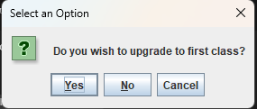
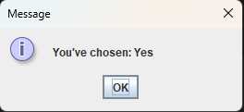
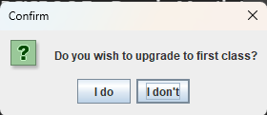

Exercise 2.2.7 – Days in Month
Description:
The program calculates the number of days in a given month and year. Leap years are handled correctly.
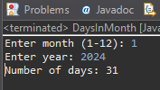

Exercise 2.2.8 – Equation Solver
Description:
This program allows users to solve:
- Linear equations
- Systems of linear equations
- Quadratic equations
The program uses dialog boxes for input and output.
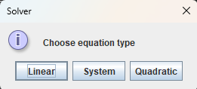
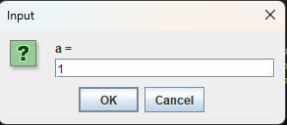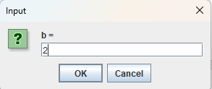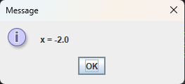

3. Conclusion
Through this lab, I have practiced basic Java programming skills, including:
- User input handling
- Conditional logic
- Loops and arrays
- Simple GUI dialogs using JOptionPane
This lab helped strengthen my understanding of fundamental Java concepts and prepared me for more advanced object-oriented programming tasks.

4. References
- Java SE Documentation
- Course slides: Object-Oriented Programming – HUST

